2020 DENVER, CO 8th GRADE MISSION TRIP
Dates: July 8-14, 2020
Trip Leader: Dylan Bone
APPLICATION DUE: October 20, 2019
Partner Church Information: Journey Point Church is a new church plant in the city of Denver, that launched fall 2018. Our first services were November 4th, December 2nd, January 6th, then launching February 10th. Stapleton is home to the largest urban infill redevelopment project in the country as they decided in the early 2,000s to turn the old Denver Airport into a Community-centric neighborhood. Stapleton is now home to more than 50,000 residents, with an average age of 33.4 and close to 2 kids per home, and an anticipated 3,000 new homes in the next 36 months. It’s one of the fastest growing communities in the Denver area and a largely desirable community. Our church is gospel centered, with a strong emphasis on disciple-making and leadership development. Our sole purpose and mission is to “point people on a journey with Jesus.”
Partner Church Staff/Leadership Information: Chris and Libby Phillips have been married for over 11 years and have 4 children, Tripp (9), Paxton (7), Rhett (5), and Henley Grace (21 months). We’re originally from TN and Chris has been in full-time ministry as a pastor for over 6 years, where I was previously a Medical Device Representative. Libby has her master’s in early childhood education and is our Children’s Ministry Director on top of her job as a Kindergarten Teacher (at the school where we’re worshipping!).
Seth Taylor, our Connections Pastor, and his wife are originally from Kentucky, but have lived in Denver for over 2 years. Seth and Lea have a 2-year-old daughter Eliza. Seth served as an intern at a church plant here in Denver but joined the Journey Point team last year where Seth is overseeing all of our setup/teardown, missions efforts, and small groups.
Trip Purpose: The desire and purpose for the trip is for exposure and service in our community and at our church.
Ministry Activities: (a) Hang door hangers, serve coffee and donuts, host block parties, serve first responders, serve elementary schools, and other opportunities; and (b) helping Journey point load in, set up, take down, and load out their mobile church as well as serve in the children’s ministry to give volunteers a much needed break.

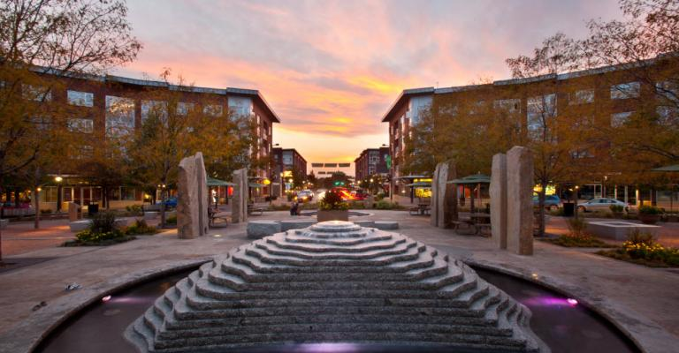
Geographic Information: Sitting at 5,280 feet, Denver is the mile-high city. With the changing climate, make sure to pack in layers, as you never know when you’ll wake up with 30 degrees, have lunch at 75, and go to bed around 40. Stapleton is a mix of urban and suburban. Stapleton is lost. There is a large same-sex population here and that is something to adjust to when visiting. The constant reminder is that we love the sinner, but hate the sin. Out of 50,000+ people in Stapleton, only 500 are worshipping in a church weekly, therefore when you encounter people, they’re more than likely not in a relationship with Jesus. Those not in a relationship with Jesus, act like people not in a relationship with Jesus. With the amount of projects, going on, I’d pack lightly, and in layers to accommodate the changing climate and potential days in the mountains.
Health Considerations: Staying hydrated will be a priority. There will also be a lot of walking involved.
Clothing: Please bring modest clothing. Colorado is known for “Colorado Casual” and you’ll see most people in flip flops, jeans, and a t-shirt. No formal dress is needed.

Lodging and Transportation: The team will stay the Holiday Inn in Stapleton. They will drive rental vans from OKC to Denver and use those vans to get around the city.

Deposit and Trip Cost: $125 nonrefundable deposit. Because logistics are still being determined, the full cost of the trip and a payment plan will be given at the first mission trip meeting on October 27, 2019. Give payments to Student Ministry Staff or place in the mailboxes in the student building.
Registration: You must pay a deposit of $125 by check or cash. All participants are required to fill out a mission trip application. In order to secure your spot the application and deposit must be turned in together.

MEETINGS
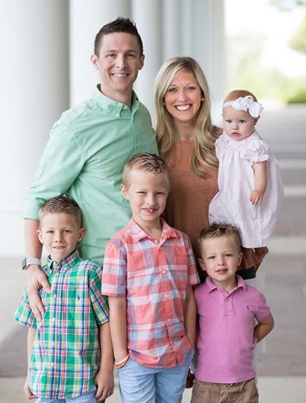
First Meeting: October 27, 2019 at 7:30 pm. Parents are encouraged to attend this meeting. It will be in the Middle School Room.
Calendar: Reserve the dates and times for remaining meetings. These meetings are required and important for preparation. Dylan Bone if you cannot make a meeting.
- January 26, 2020 at 7:30pm
- February 23, 2020 at 7:30pm
- March 29, 2020 at 7:30pm
- April 26, 2020 at 7:30pm
- May 24, 2020 at 7:30pm
- June 28, 2020 at 7:30pm – Parents need to attend this meeting

Homework: Complete assignments before each meeting.

FUNDRAISING IDEAS
WHO IS THIS FOR?
Anyone that needs to raise money! Any cause, adoption, mission trip, non-profit, etc. You need to raise money, we want to help you!
HOW DOES ALL OF THIS WORK?
Check out our HOW IT WORKS page.
CAN I PERSONALIZE THE SHIRTS? (CHURCH NAME, TRIP, DATES, ETC.)
Yes. Whatever you want on the shirt, we'll try to make it happen! This is one of the many great things about FTN. No stock designs here. We designs shirts just for your cause!
CAN I MIX & MATCH BETWEEN DESIGN & SHIRTS IN MY ORDER?
The easy answer is no. If you want to place separate orders, we can make it happen. But, to mix & match between orders would cause the price to increase, decreasing your profit for your fundraising. If you want to place a completely separate order with a separate design, just let us know!

WHAT IS THE PRICE PER SHIRT?
Several factors go into the price of a shirt, including the type and color of shirt, how many colors are in the graphic, how many locations (front, back, sleeve) of the shirt are printed, and the quantity of shirts ordered. We try to keep fundraising shirts between $6-9.50 depending on the specifics. Contact us for specific price questions!
WHAT IS INCLUDED IN THE "PRICE PER SHIRT"?
Everything! Design, shirt, set-up, print, packing, and shipping. The price per shirt is the cost it takes to get it in your hands!
HOW MUCH SHOULD I RE-SELL THE SHIRTS FOR?
We suggest $20 per shirt. That may seem steep, but think about it this way: GAP has their (RED) campaign shirts (to support AIDS research) priced around $30 per shirt, for a simple red t-shirt. And people pay it because of where the money is going. The same is true for your shirt. People aren't just buying a t-shirt, they're investing in your cause! You may be surprised at how much people will want to help you and want a t-shirt from you.
*this is just a suggestion, feel free to sell the shirts for whatever you'd like!
HOW LONG DOES THIS PROCESS TAKE?
The selling process can be a short or as long as you want. Once you give us the sizes, it typically takes between 7-9 business days (M-F) to get the shirts shipped out from us! If you need them by a certain date, please let us know!
HOW DO THE SHIRTS FIT? (BIG, SMALL, TRUE TO SIZE?)
FTN uses a variety of different brands based on your needs and/or desires. If you have one in mind, just ask! Every brand runs differently in how it fits and so once we have a design and shirt picked out for you we would be more than willing to let you know how (our opinion) that specific brand fits (and if it shrinks or not when washing).
WHY DO YOU NOT HAVE ANY KIND OF WEB-STORE OR CROWDFUNDING PLATFORM ON YOUR WEBSITE?
FTN believes that the power to sell these shirts lies within the "circle" of people around you... family, friends, church members, classmates, social media connections, etc. Crowdfunding is great with some needs and ideas, but your personal shirt is going to sell much better to people with whom you're already connected! They believe in you and want to support you...and we stand behind that method of selling because we've seen it help a ton of people accomplishing their calling!
WILL YOU DESIGN & PRINT SHIRTS FOR SOMEONE THAT'S NOT FUNDRAISING?
Absolutely! Check out our non-fundraising brand, 52Threads! Churches, youth groups, camps, baseball teams, schools, etc. Doing so actually enables us to do more fundraising, so know that when we design & print your shirts, it's ultimately for the cause of the Gospel!
5 SIMPLE STEPS TO RAISING FUNDS
We want to make this as easy as possible for you...
1) CONTACT US
From the GET STARTED and let us know what you're raising money for.
2) WE CREATE A DESIGN FOR YOU
To check out. (It always helps if you let us know anything specific you would want for your design; we'll work until it's exactly the way you want it!)
3) ONCE YOU'VE GOT A DESIGN YOU LIKE
You then take the image of the shirt and pre-sell as many as you can! (kind of like girl scout cookies!)
Best ways to do that are through:
A) circle of immediate friends and family,
B) social media (Facebook-- some even create a page, twitter, Instagram, etc.)
C) your local church
D) work/school
4) YOU SUBMIT YOUR ORDER
using the order link we'll share with you during the fundraising process.
5) WE PRINT AND SHIP THE SHIRTS TO YOU
for distribution! You now have the funds to go and change the world....It really is that easy!
*no money is required upfront, only once you email us with the sizes you need.
"Money should not determine your vision, just fund it."

Pick a Number

A "Pick a Number" is a large board (or whatever else you decide to use) with a bunch of numbers on it. The numbers include every number from 1-70, and they can be on the board in order or all mixed up (get creative!). The idea is that friends and family can "Pick a Number" to donate.

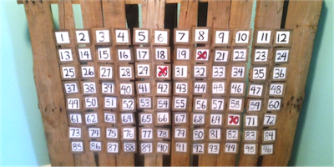
Once they pick a number, that number is taken off the board (or X'ed out). This board could be set up at school, church, or work. And check this out - If all 70 numbers are taken, you'll raise $2,485. If only half of the numbers are taken, you'll still raise over a thousand dollars! And no single person had to give more than $70.

Note: Putting 40 numbers will get everything fundraised, even your spending money!

Create and sell a product
We have seen tons of creativity from mission trip participants who have made and marketed their own products to raise the funds for their mission trips. If you plan on serving on mission trips on a regular basis, you might consider setting up an online storefront on a website like Etsy.com to bring money into your mission trip savings account year-round.
Art. For the artistically gifted, Javier Perez, manager of missions and humanitarian aid, suggests an art auction featuring a gallery of pictures and paintings.
Food. Many people know that the way to another’s heart is through their stomach, so they head to the kitchen to make and sell delicious treats. Melanie Miller and Brittani Cirinna baked hundreds of cake pops, while Ada Sanchez sold homemade empanadas.
T-shirts. A custom T-shirt is always a popular choice. Krista Askey and Morgan Shamasko had shirts custom designed and printed to raise money for their trips to Africa.
Provide a service
Are you good at cutting kids’ hair? Are you handy with a hammer? Do you scrapbook, or thrive on home organization? Think about what you’re good at doing for yourself – maybe you could do the same thing for others and earn some extra money. Here are a few other ideas:
• Repair computers
• Mow lawns
• Do oil changes
• Shovel snow
• Bake special occasion cakes
• Walk or groom pets, or pet-sit
• Tutor students
• Style hair for formal events
• Sharpen knives and lawnmower blades
• Edit cover letters and resumes
• Officiate local sporting events
• Babysit
Sell Wristbands to Support the Cause
Bracelets or wristbands are popular item that can be purchased in support of a mission trip. Fundraising ideas involving wristbands could include offering customized wristbands that have your group's inspirational message printed on them, the location, and the year.
Wristband Resources has a great selection of quality silicone wristbands that would be perfect for this. They also have more than 20 years of experience in providing custom wristbands. Our products are all high-quality and we have trained support staff available to assist you both during the ordering process and after an order has been placed. We also offer live online support. Orders are processed quickly for fast turnaround so you'll have your wristbands in plenty of time for your mission trip fundraiser.
Write a Mission Trip Support Letter
See additional document for details on how to write a mission trip support letter and samples of mission trip support letters.
Donations for Your Trip
- Make checks payable to QSBC (DO NOT WRITE STUDENT NAME IN MEMO LINE).
- Include a written note that states Student’s Name and the Mission Trip Name.
- Mail to QSBC (14613 N. May Avenue Oklahoma City, OK 73134), Attn: Courtney Dishman

