2020 PUERTO RICO HS MISSION TRIP
Dates: July 11-17, 2020
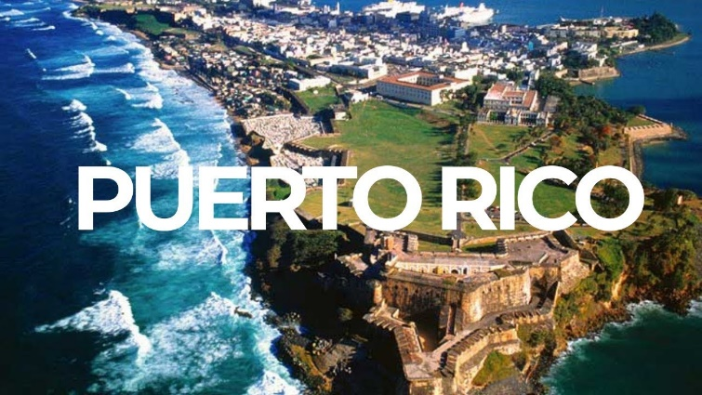
Team Members: 30 participants (25 Students, 5 Adults)
Basic Trip Information: When Hurricane Maria struck Puerto Rico in 2017 devasting people and property, the need for action was immediate. There is still a need for relief efforts, so Send Relief established a ministry center with a desire to give people an opportunity to share the gospel. Teams of volunteers assist local churches in meeting the needs in their community, showing mercy and compassion through hand-on engagement.
Partner Church Staff/Leadership Information: We will be working closely with Felix Cabrera (former pastor of Iglesias Bautista Church on QSBC Campus). He is planting a church in Puerto Rico and overseeing many of the NAMB Send Relief Projects
Trip Purpose: Our hope for this group is to help serve the community and open doors to share the gospel. Our goal in all of this is to see lives changed for the cause of Christ.

Ministry Activities: (a) community engagement (b) aid with foster care and adoption; (c) construction and community revitalization; (e) helping families and churches in the process of rebuilding; (f) brush and debris removal; (g) and demolition/cleaning.

Geographic Information: Puerto Rico, officially known as the Commonwealth of Puerto Rico (Estado Libre Asociado de Puerto Rico), is an unincorporated territory of the United States, located in the northeastern Caribbean, east of the Dominican Republic and west of both the U.S. Virgin Islands and the British Virgin Islands. Puerto Rico is only 100 miles long by 35 miles wide, making it the smallest island of the Greater Antilles. Puerto Rico (Spanish for "rich port") consists of an archipelago that includes the main island of Puerto Rico and several islands: Vieques, Culebra, Mona and numerous islets. Daily high temperatures are around 88°F. Daily low temperatures are around 78°F.

Health Considerations: We will walk a lot and be outside a lot. No immunizations are required for this trip. But if you need more information check here: https://wwwnc.cdc.gov/travel/destinations/traveler/none/puerto-rico.
What to Bring: Please bring modest clothing. Closed-toe shoes, long pants (for work sites), clothes that can be ruined. Modest clothes to sleep in. Hat of some type. Personal water bottle. Sunscreen. Bug spray. Sunglasses. Toiletries. Bedding and Pillow. Towel. Nicer outfit for church attendance. Umbrella/Raincoat. Work gloves. Medium-length clothes. Bible. Journal.

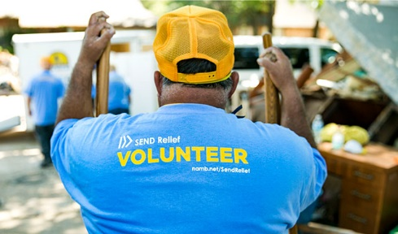
Lodging, Meals, and Transportation: The team will stay in secure housing provided by NAMB Send Relief. Accommodations are gender-separated. We will be sleeping in dorm like housing. Meals consist of local foods. They provide breakfast, lunch, and dinner. We will fly from OKC to Puerto Rico. Once we are at the airport, transportation is provided by NAMB Send Relief. They will pick us up from the airport, shuttle us from work sites, etc.

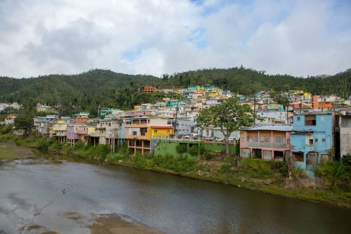
Deposit and Trip Cost: $125 nonrefundable deposit. Because logistics are still being determined, the full cost of the trip and a payment plan will be given at the first mission trip meeting on October 27, 2019. If you withdraw from the trip after the plane tickets are purchased, you are responsible to pay for your ticket. Give payments to Student Ministry Staff or place in the mailboxes in the student building.
Registration: All participants are required to pay your deposit by check. All participants are required to fill out a mission trip application. In order to secure your spot the application and deposit check must be turned in.

FINANCIAL BREAKDOWN AND PAYMENT PLAN
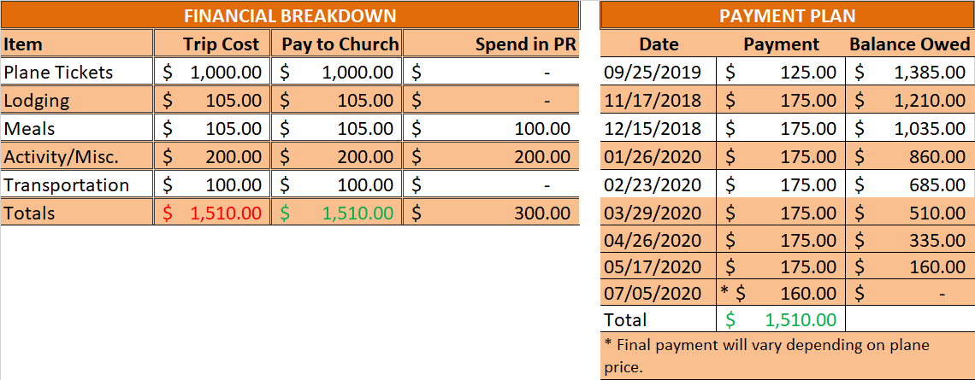

MEETINGS
First Meeting: October 27, 2019 at 6:30 pm. Parents are encouraged to attend this meeting.
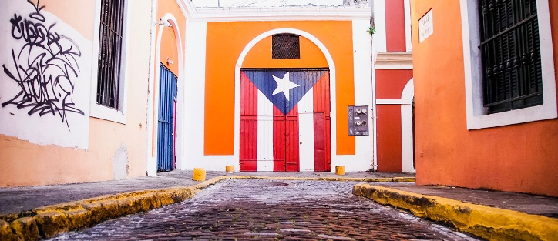
Calendar: Reserve the dates and times for remaining meetings. These meetings are required and important for preparation. Contact Jeff DeGiacomo if you cannot make a meeting.
- November 17, 2019 at 6:30pm
- January 26, 2020 at 6:30pm
- February 23, 2020 at 6:30pm
- March 29, 2020 at 6:30pm
- April 26, 2020 at 6:30pm
- May 17, 2020 at 6:30pm
- July 5, 2020 at 6:30pm – Parents need to attend this meeting.
Homework: Complete assignments before each meeting.

FUNDRAISING IDEAS
WHO IS THIS FOR?
Anyone that needs to raise money! Any cause, adoption, mission trip, non-profit, etc. You need to raise money, we want to help you!
HOW DOES ALL OF THIS WORK?
Check out our HOW IT WORKS page.
CAN I PERSONALIZE THE SHIRTS? (CHURCH NAME, TRIP, DATES, ETC.)
Yes. Whatever you want on the shirt, we'll try to make it happen! This is one of the many great things about FTN. No stock designs here. We designs shirts just for your cause!
CAN I MIX & MATCH BETWEEN DESIGN & SHIRTS IN MY ORDER?
The easy answer is no. If you want to place separate orders, we can make it happen. But, to mix & match between orders would cause the price to increase, decreasing your profit for your fundraising. If you want to place a completely separate order with a separate design, just let us know!

WHAT IS THE PRICE PER SHIRT?
Several factors go into the price of a shirt, including the type and color of shirt, how many colors are in the graphic, how many locations (front, back, sleeve) of the shirt are printed, and the quantity of shirts ordered. We try to keep fundraising shirts between $6-9.50 depending on the specifics. Contact us for specific price questions!
WHAT IS INCLUDED IN THE "PRICE PER SHIRT"?
Everything! Design, shirt, set-up, print, packing, and shipping. The price per shirt is the cost it takes to get it in your hands!
HOW MUCH SHOULD I RE-SELL THE SHIRTS FOR?
We suggest $20 per shirt. That may seem steep, but think about it this way: GAP has their (RED) campaign shirts (to support AIDS research) priced around $30 per shirt, for a simple red t-shirt. And people pay it because of where the money is going. The same is true for your shirt. People aren't just buying a t-shirt, they're investing in your cause! You may be surprised at how much people will want to help you and want a t-shirt from you.
*this is just a suggestion, feel free to sell the shirts for whatever you'd like!
HOW LONG DOES THIS PROCESS TAKE?
The selling process can be a short or as long as you want. Once you give us the sizes, it typically takes between 7-9 business days (M-F) to get the shirts shipped out from us! If you need them by a certain date, please let us know!
HOW DO THE SHIRTS FIT? (BIG, SMALL, TRUE TO SIZE?)
FTN uses a variety of different brands based on your needs and/or desires. If you have one in mind, just ask! Every brand runs differently in how it fits and so once we have a design and shirt picked out for you we would be more than willing to let you know how (our opinion) that specific brand fits (and if it shrinks or not when washing).
WHY DO YOU NOT HAVE ANY KIND OF WEB-STORE OR CROWDFUNDING PLATFORM ON YOUR WEBSITE?
FTN believes that the power to sell these shirts lies within the "circle" of people around you... family, friends, church members, classmates, social media connections, etc. Crowdfunding is great with some needs and ideas, but your personal shirt is going to sell much better to people with whom you're already connected! They believe in you and want to support you...and we stand behind that method of selling because we've seen it help a ton of people accomplishing their calling!
WILL YOU DESIGN & PRINT SHIRTS FOR SOMEONE THAT'S NOT FUNDRAISING?
Absolutely! Check out our non-fundraising brand, 52Threads! Churches, youth groups, camps, baseball teams, schools, etc. Doing so actually enables us to do more fundraising, so know that when we design & print your shirts, it's ultimately for the cause of the Gospel!
5 SIMPLE STEPS TO RAISING FUNDS
We want to make this as easy as possible for you...
1) CONTACT US
From the GET STARTED and let us know what you're raising money for.
2) WE CREATE A DESIGN FOR YOU
To check out. (It always helps if you let us know anything specific you would want for your design; we'll work until it's exactly the way you want it!)
3) ONCE YOU'VE GOT A DESIGN YOU LIKE
You then take the image of the shirt and pre-sell as many as you can! (kind of like girl scout cookies!)
Best ways to do that are through:
A) circle of immediate friends and family,
B) social media (Facebook-- some even create a page, twitter, Instagram, etc.)
C) your local church
D) work/school
4) YOU SUBMIT YOUR ORDER
using the order link we'll share with you during the fundraising process.
5) WE PRINT AND SHIP THE SHIRTS TO YOU
for distribution! You now have the funds to go and change the world....It really is that easy!
*no money is required upfront, only once you email us with the sizes you need.
"Money should not determine your vision, just fund it."

Pick a Number

A "Pick a Number" is a large board (or whatever else you decide to use) with a bunch of numbers on it. The numbers include every number from 1-70, and they can be on the board in order or all mixed up (get creative!). The idea is that friends and family can "Pick a Number" to donate.

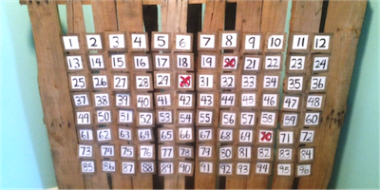
Once they pick a number, that number is taken off the board (or X'ed out). This board could be set up at school, church, or work. And check this out - If all 70 numbers are taken, you'll raise $2,485. If only half of the numbers are taken, you'll still raise over a thousand dollars! And no single person had to give more than $70.

Note: You don't have to have exactly 70 numbers. Adjust up or down depending on the funds you need to raise!

Create and sell a product
We have seen tons of creativity from mission trip participants who have made and marketed their own products to raise the funds for their mission trips. If you plan on serving on mission trips on a regular basis, you might consider setting up an online storefront on a website like Etsy.com to bring money into your mission trip savings account year-round.
Art. For the artistically gifted, Javier Perez, manager of missions and humanitarian aid, suggests an art auction featuring a gallery of pictures and paintings.
Food. Many people know that the way to another’s heart is through their stomach, so they head to the kitchen to make and sell delicious treats. Melanie Miller and Brittani Cirinna baked hundreds of cake pops, while Ada Sanchez sold homemade empanadas.
T-shirts. A custom T-shirt is always a popular choice. Krista Askey and Morgan Shamasko had shirts custom designed and printed to raise money for their trips to Africa.
Provide a service
Are you good at cutting kids’ hair? Are you handy with a hammer? Do you scrapbook, or thrive on home organization? Think about what you’re good at doing for yourself – maybe you could do the same thing for others and earn some extra money. Here are a few other ideas:
• Repair computers
• Mow lawns
• Do oil changes
• Shovel snow
• Bake special occasion cakes
• Walk or groom pets, or pet-sit
• Tutor students
• Style hair for formal events
• Sharpen knives and lawnmower blades
• Edit cover letters and resumes
• Officiate local sporting events
• Babysit
Sell Wristbands to Support the Cause
Bracelets or wristbands are popular item that can be purchased in support of a mission trip. Fundraising ideas involving wristbands could include offering customized wristbands that have your group's inspirational message printed on them, the location, and the year.
Wristband Resources has a great selection of quality silicone wristbands that would be perfect for this. They also have more than 20 years of experience in providing custom wristbands. Our products are all high-quality and we have trained support staff available to assist you both during the ordering process and after an order has been placed. We also offer live online support. Orders are processed quickly for fast turnaround so you'll have your wristbands in plenty of time for your mission trip fundraiser.
Write a Mission Trip Support Letter
See additional document for details on how to write a mission trip support letter and samples of mission trip support letters.
Donations for Your Trip
- Make checks payable to QSBC (DO NOT WRITE STUDENT NAME IN MEMO LINE).
- Include a written note that states Student’s Name and the Mission Trip Name.
- Mail to QSBC (14613 N. May Avenue Oklahoma City, OK 73134), Attn: Courtney Dishman

